PRODUCT DETAILS

**Guess Watch W1454G1**

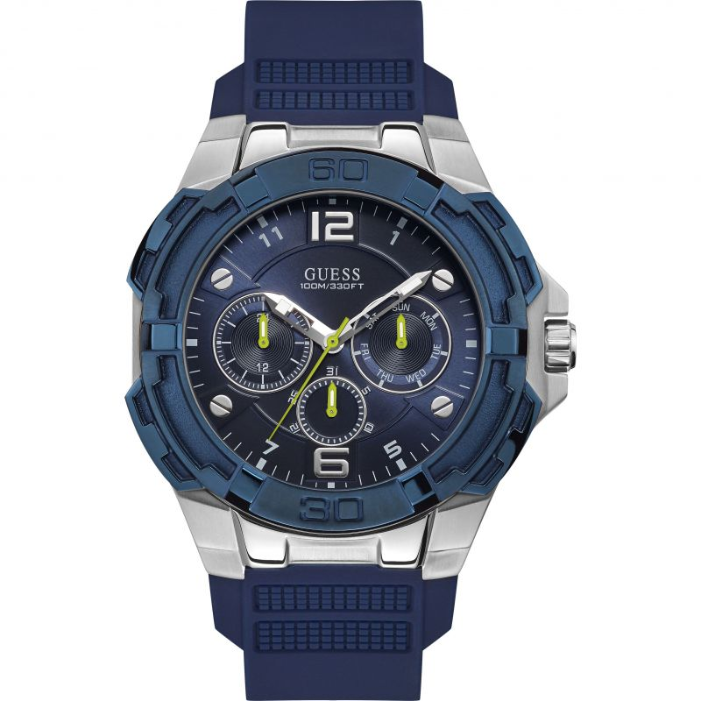

**$189.00**

**Specifications**

**Brand:** Guess

**Analogue/Digital:** Analogue

**Primary Material:** Stainless Steel

**Case Shape:** Circle

**Clasp type:** Strap buckle

**Dial Color:** Blue

**Gender:** Gents

**Glass:** Mineral

**Movement Source:** Japan

**Movement:** Quartz

**Strap colour:** Blue

**Strap type:** Rubber Strap

**BARCODE:** 091661495427

**Guarantee:** 2 years